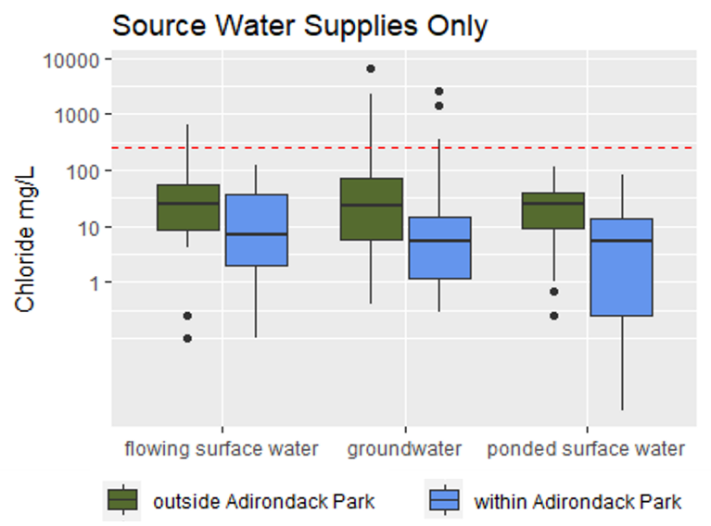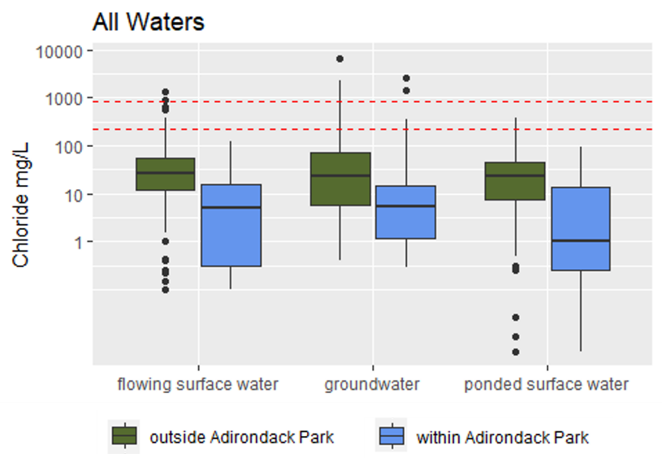

Figure 2: Median chloride concentrations in surface water and groundwater source water supplies within (blue) and outside(green) the Adirondack park. Red lines delineate NYSDEC’s chloride water quality standard for source water supplies.

Figure 1: Median chloride concentrations in surface water and groundwater sampling locations within (blue) and outside(green) the Adirondack Park. Red lines delineate EPA’s recommended chronic (230 mg/L) and acute (860 mg/L) aquatic life criteria.

**Key Points**

* Surface water and groundwater chloride concentrations are generally lower within the Adirondack Park compared to the rest of the state according to data collected by NYSDEC monitoring programs.
* NYSDEC’s chloride water quality standard is only applicable to source water supplies. Among the source water supplies in the Adirondack Park, three sampling locations exceeded NYSDEC’s. All of these locations were ground water supplies. These samples represent 5% of all groundwater sampling locations and 2% of all source water supply sampling locations.
* Three ground water sampling locations and none of the surface water sampling locations exceed EPA’s recommended chronic (230mg/L) aquatic life criteria. These samples represent 5% of all groundwater sampling locations and 1% of all source water supply sampling locations.
* Should NYSDEC adopt EPA’s aquatic life criteria, the 75th percentile would be considered the stressed condition.